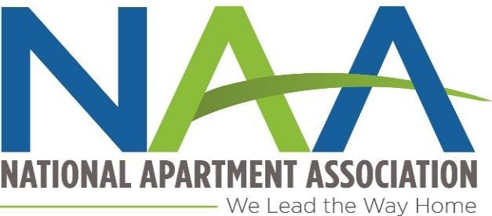
NAA LIFETIME ACHIEVEMENT AWARD CALL FOR NOMINATIONS

The NAA Lifetime Achievement Award recognizes the contributions of our supplier partners and our association executives for their "long-term history of exemplary national service and accomplishments to the National Apartment Association and the apartment industry. The criteria for nominations are exemplary service to NAA and the apartment industry overall, above and beyond that of the normal member volunteer: length of time in the industry is not a determining factor but is a consideration.

The Hall of Fame Committee will oversee the Lifetime Achievement Award (LAA) each year. The Chairman of the NSC and the President of the AEC will be added to the committee to review nominations for the LAA. The LAA awards may be awarded to both a supplier member and an association executive; only in one category; or not at all if the Committee so determines. This is not an annual award. It is designed to recognize outstanding service to NAA beyond the efforts of other volunteer leaders. Nominees from previous years who were not selected may be resubmitted for consideration.

A recipient must be a former or current member/AE of NAA and will be determined by a vote of 8 of the 11 members. The presentation of the award will be given during the 2017 Assembly of Delegates in November at Fort Worth, TX.

Marc Ross, CAPS
Chairman of the 2017 Hall of Fame Committee has issued this Call for Recommendations
for the Lifetime Achievement Award YOUR NAME
I wish to recommend the following member to the Hall of Fame Extended Committee for consideration for the Lifetime Achievement Award in 2015.

NAME COMPANY CITY/STATE
A brief summary outlining the contributions this person has made to the industry and NAA that would warrant his/her consideration by the Hall of Fame Committee for the LAA must be submitted.

You may request this form be emailed to you for completion lmiller@naahq.org
PLEASE RETURN DOCUMENTS TO Judy Reynolds BY
July 31, 2017

