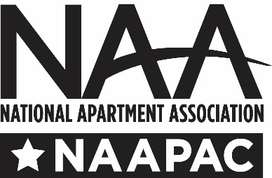
NAAPAC is an essential part of government affairs. It allows us to support candidates who understand our issues and who are likely to be helpful to us. NAA itself cannot use its funds to make contributions to candidates, so the NAAPAC is funded through voluntary contributions from employees at our member companies. But, the Federal Election Commission adds another step to the process. Before we can solicit any employee of a member corporation for a contribution to NAAPAC, federal law requires us to obtain your permission to solicit. Please note that this permission is ONLY required from member corporations: LLCs, partnerships, etc., are not required to provide this permission.

By signing below I grant NAAPAC to solicit my company’s restricted class (please see side note below) for the years indicated. I certify that my company is currently a member of NAA or an NAA affiliate and that for the years indicated, my company cannot authorize another trade association to solicit political contributions for federal candidates from my company’s restricted class. Approval to solicit does not obligate me or my employees to contribute to NAAPAC. (Please print clearly or attach a business card.)
May we have your official permission to help the industry?
Name: __________________________________________ Title: _______________________________
Company: ____________________________________________________________________________
Street: _______________________________________________________ Suite: __________________
City: ___________________________________________ State: _________ ZIP: __________________
Telephone: (______) ____________________Ext: ______ email: _______________________________

[ ] My business is incorporated. I authorize the NAAPAC to solicit myself and my employees for contributions for the years designated below. (Sign each calendar year for which approve is given.)
2021________________________________________________
Your company’s restricted class includes “executive and administrative personnel” and shareholders. Executive and administrative personnel includes salaried employees with decision-making authority, but does not include salaried foremen. Should you have any questions about the restricted class, please contact NAAPAC.

2022 _______________________________________________
2023 _______________________________________________
2024 _______________________________________________
2025 _______________________________________________
[ ] NAAPAC may solicit only me
[ ] My company will handle the solicitation, please send me the
materials
Please attach a list of employees for whom you are granting NAAPAC to permission to solicit, including name, title, telephone number and email address.
Please send this form and all attachments as follows:

EMAIL to pac@naapac.org
MAIL to NAAPAC, 4300 Wilson Blvd., Suite 800, Arlington, VA 22203

